Reedcross Before the Flood
  - Public Draft · v0.9
Produced by Terrible Gamers with writing, editing, and design done by Scott Mills and Mira Vale.

Introduction
One of my greatest difficulties when I started running games for others years ago was feeling like it was my responsibility to create stories, NPCs, and campaigns out of whole cloth. That expectation acted like a block to my writing. I really felt like I could not come up with a good outline for a story. I felt much more creative as a GM when I had something to build on. A scene from fiction, a published adventure, or something another GM had done could give me a starting point. Those templates made it easier to create something of my own.
Portraying NPCs and describing actions and consequences came more easily to me than writing campaigns, adventures, or encounters. I often felt like an impostor as a GM. Even so, I enjoyed playing and running games enough to keep working through those creative blocks. My players’ feedback helped me grow more comfortable with my designs.
One of my original Terrible Gamers articles was a GM workshop, written to give readers a glimpse into my creative process as I was designing a campaign setting based on a modern interpretation of Twilight 2000. By then, I was much better at writing things independently, but I still wanted—and still want—easier access to small, ready-made scenarios and encounters that I can make my own. Mira and I created this latest GM Workshop with that need in mind.
Reedcross Before the Flood is a system-neutral scenario for fantasy or medieval games. It supplies a cast of NPCs (I am also terrible at naming them), a ferry crossing threatened by a flood, and a practical problem under time pressure that players need to solve. Several workable plans and solutions to that problem are included, but remember that the role of a GM is not to drive your players along rails. Players may find other creative solutions on their own, and a good GM always allows space for this. You can run it as written or borrow the people and predicament for something of your own. We hope you find this useful and enjoy the stories Reedcross helps you create!

The Scenario
A drop-in river-crossing scenario for an existing adventure or campaign, written for three to five beginning adventurers. Use it as a brief obstacle or let its people and competing interests develop into a substantial event. It has no prescribed session length; a quick, competent resolution is a successful use of the material.

The Predicament
Rain has fallen for days, and another hard shower drums on the ferry-house roof as the characters reach Reedcross. Here the River Alder runs from north to south, with the party and eighteen adult travelers on its low west bank. This is the only working crossing for miles; the return road has disappeared under brown water. Across the river, a raised road leads to the residents' homes and the traders' onward journeys. That road and those homes remain above the flood.
The ferry is a broad, flat-bottomed boat with six passenger-sized spaces, in addition to Pella Rusk at the controls. Each person and their personal pack use one space; each of the company's three marked iron-goods crates uses two. The boat is sound, but the hauling lever has a broken pin. Pella, its owner and operator, knows how to repair it. Sorn Vale, the carrying company's local cargo agent, initially refuses to release the tool-shed key unless his employer's shipment goes first.
The danger is immediate, but the disagreement is not simply greed against kindness. Pella Rusk needs to keep people alive and preserve the boat she works from. Sorn Vale has personally guaranteed goods bought on credit. The porters beside his crates are still owed wages. A workable agreement could protect lives and livelihoods; an argument that goes nowhere will steadily narrow the choices.
The broken quarry stair on the west bank offers a second route to safety once supported with the available planks or ladder and rope. It does not cross the river. Using it can avoid the ferry dispute or free ferry spaces for goods, but leaves its users west of their intended destination.

Using Reedcross in Your Campaign
Place Reedcross along a journey the characters already have reason to make. Choose a connection that suits your game rather than assigning them a new obligation:
- An onward journey: the party needs the eastward road to reach an existing destination, appointment, or employer. Wanting passage does not automatically mean taking charge of everyone else's crossing.
- Paid work: the characters might be caravan guards hired to meet some of the six traders at Reedcross, or Dema Orrel, a returning resident entrusted with several households' planting seed, might have hired them to meet her here and bring it home. Their employers and goods come from the existing traveler inventory, and the party arrives for that meeting as the opening dispute unfolds. Agree what the job covers, what earns payment, and what failure would mean; a cargo contract need not oblige them to evacuate every stranger. Dema's small seed sack is already her personal luggage. Added caravan wagons, animals, or goods require the capacity changes in section 10.
- Personal ties: a traveler is an established friend, relative, patron, or companion. Use an existing relationship or agree one with the players before play.
- A wider danger: people and cargo might be fleeing an approaching army, a raiding force, or a magical blight spreading across the countryside. This is an optional campaign context, not an extra threat in the default scenario.
In the default scenario, the west-bank quarry shoulder provides real safety from the flood. The residents want to get home along the high east road, and several households are relying on Dema's seed for planting. The independent traders want to get themselves and their goods across so they can continue their journeys with their livelihoods intact; their personal packs fit their personal spaces. The company's three iron-goods crates are a separate consignment. Waiting or losing goods has material consequences, but no approaching enemy makes eastward travel compulsory. A higher-stakes adaptation may change that choice: establish the wider threat, what the characters know, and whether west-bank refuge offers lasting safety before they commit.
Ask whether flood peril, threatened livelihoods, and intimidation suit the table. The default travelers are adults. Adding dependents, animals, or extra property changes the rescue and its capacity.

Make the Situation Your Own
Use the situation as part of the larger adventure, not a required sequence of scenes. Rename the locality, connect the shipment to an existing settlement, or adapt the personalities. Let decisions and their consequences determine how much play it occupies. Once the immediate predicament is resolved, continue the journey; do not add a fight, failure, or new disaster merely to fill time. Further complications should follow from the campaign's established circumstances.

1. People to Portray
Eighteen adult travelers are waiting, in three groups:
- Eight returning residents, including Dema Orrel and Harl Nenn.
- Six independent traders, including Brin Vetch.
- Four company people: Sorn Vale and the three porters, Tavi Pell, Renn, and Udel.
Pella Rusk is additional: the ferry's owner and operator, not one of those eighteen travelers. The characters are additional too. The remaining unnamed travelers need individual descriptions only when they speak.
This version uses human NPCs and ordinary late-medieval equipment; no magic is needed for a printed solution. Adapt ancestries, appearances, and equipment to your campaign. Account for different carrying sizes in section 10.

The Competing Groups
The returning residents want fair passage and the boat preserved; their resources are willing hands, local knowledge, and limited savings. Dema favors a written list. Another resident offers coins just to end the argument, but it is not enough to cover the price of Sorn’s goods. Harl objects to breaking a useful door if the key is obtainable. Let these disagreements produce proposals rather than speeches.
The company party wants to leave together with enough value to preserve work; its existing wage debt can be settled from the office cash, independently of saving the shipment. Sorn fears the recorded loss; Tavi fears being made to risk people for it. Renn follows a calm loading instruction. Udel asks whether the blanket can go to someone already shivering. Their clubs deter rough handling of the crates; they do not make them dedicated guards.
The independent traders are a swing group. Some trust Pella; others think Sorn is protecting his employees. Brin will leave an argument that has stopped producing decisions. They can witness an inventory without accepting its debt or join a stair crew without joining either faction.
The portrayals below are starting tendencies, not compulsory responses. Danger, trust, persuasion, and a workable proposal can change what somebody does.
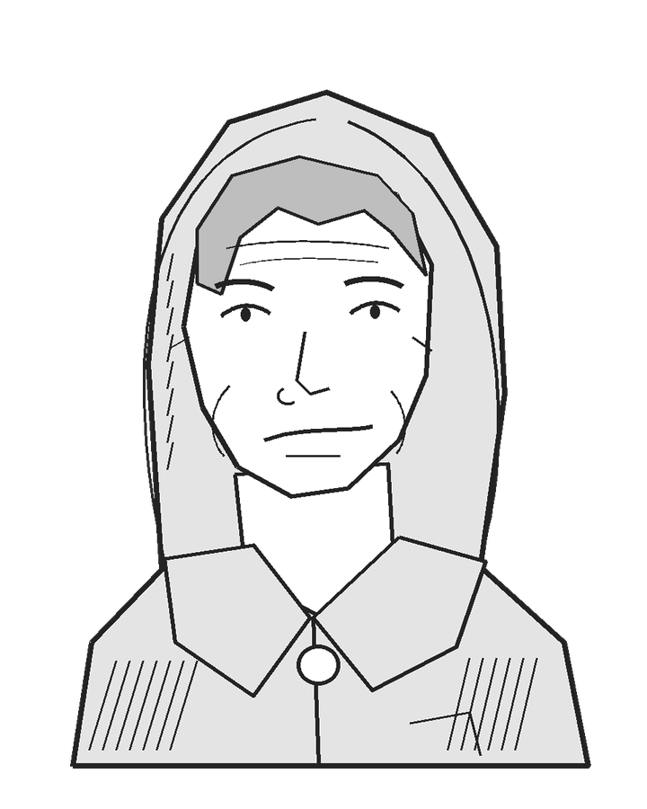 | Pella Rusk, Ferrywoman  Pella looks to be in her late forties or fifties: broad-shouldered, weathered, and wrapped in a patched oilskin hood. Her hands are cracked; she pulls at a loose cuff thread while waiting for an answer. Speak in concrete instructions. Her attention tends to leave an argument when somebody strays toward the water.
She wants everybody safe, her boat intact, and work she can continue without the concession holder treating her as disposable. She fears a passenger falling while she argues. She is embarrassed to care about the boat beside the people, but it is her livelihood.
Her leverage is competence, ownership of the ferry, and local trust. She will not knowingly overload it. She accepts cargo aboard if the manifest and timing genuinely leave a route for everyone; she does not insist on proving Sorn wrong when his plan works.
"You can be right about the concession on the dry side."
"Tell me who is staying here while that goes over."
With a witnessed inventory she becomes businesslike. If threatened, she explains the controls and asks who will operate them; she does not sabotage a rescue to defend her dignity. A character replacing her must actually have suitable competence, as judged under the chosen rules. Keep her default operation test-free.
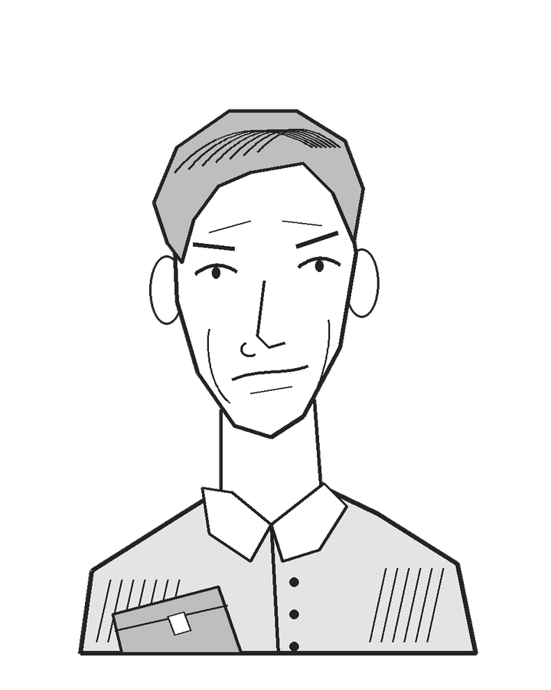 | Sorn Vale, Cargo Agent  Sorn appears to be in his late thirties or forties, with a narrow face and hair combed carefully back. He is dressed neatly but wet to the knees, and keeps wiping the clasp of his leather document case. Begin at the volume of a business discussion. Under stress he often returns to the shipment's value and the debt he may owe: “Three crates bought on my name. What do I tell them when I bring back none?”
He wants the promised iron goods delivered, the toll cash accounted for, and evidence that he fulfilled his duty. His personal credit guarantee puts his livelihood at risk. He will show the order list and guarantee if asked. The office cash can settle the porters' owed wages, but cannot erase the shipment debt. Nobody needs to visit an employer to finish this scenario.
He initially offers the key only if all crates go first. His leverage is the key, paperwork, and the porters' willingness to help. He can release emergency equipment and record losses without prior permission, although he fears the consequences. A useful bargain is a written account, signed by a credible witness, of what was saved, what was abandoned, and why. It gives him evidence for his employer, not guaranteed compensation. A slate and a spoken agreement witnessed by others can serve when paper is impractical; the form is less important than an account he can defend.
"I am trying to leave with something I can explain."
"Write that we abandoned goods to save people. Your name beside mine."
Specific witnesses, an honest salvage share, a real payment, or a feasible alternative route can move him. He asks who pilots, who carries, and who pays. As danger rises he may begin using people's names instead of shipment totals. Sorn is not looking for violence, but he may tell the porters to stop someone damaging company property. They decide whether to obey; an obviously dangerous order can lose their cooperation rather than produce an automatic attack.
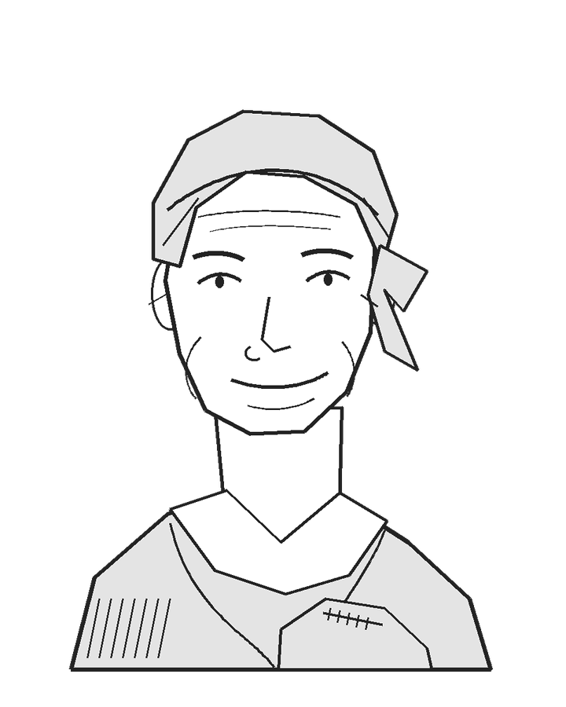 | Dema Orrel, Resident and Seed Keeper  Dema appears to be in her fifties or early sixties, with a lined, broad face beneath a tied headscarf. She holds a patched seed sack against her chest and habitually rubs a grain between thumbnail and finger. Several households contributed to these planting reserves. When rain begins soaking the sack, she asks someone to hold her place and fetches a covering from the wagon yard.
The sack and its wrapping fit her personal ferry space. Her home and the households' remaining stores are on high ground east of the river, reached by the raised road; they are not among the evacuated west-bank houses. If the iron crates are being left, their tarred sheet can cover the seed. If the crates are traveling, she looks for a spare cloth or asks the porters to help share the covering.
"If we lose the planting seed, we start borrowing before we have even sown. Some households are hungry already."
She volunteers to keep the boarding list, provided someone answers where the seed will go. She distrusts cargo priority but can support a compromise that protects livelihoods on both sides.
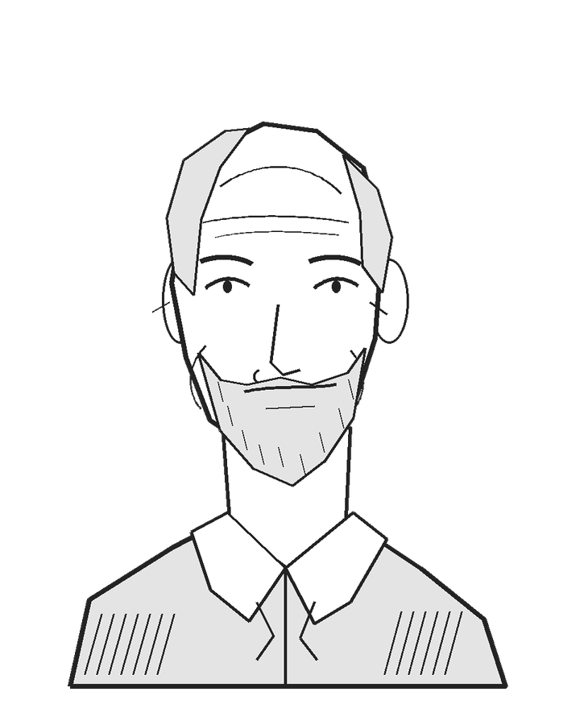 | Harl Nenn, Resident and Former Mason  Harl appears to be in his late sixties or seventies, spare-haired and short-bearded, with a direct gaze. He rises slowly, pressing a stiff knee before each step. He dislikes people discussing him as if he cannot hear. Give him a dry, practical voice. He wants a steady hand and time to move deliberately.
Harl's masonry experience can help with the quarry escape on the west bank. He can examine a plank's bearing, point out a shifting support, or advise the people securing the broken stair. Brin already knows the route and its routine preparation, so Harl is useful rather than indispensable. The stair's twenty-minute movement allowance includes people supporting him. He still occupies one ferry space; his knee adds no hidden capacity or timing penalty.
"Tell me where you want my foot. Then let me put it there."
Ask before carrying him. He prefers the ferry, but accepts a properly prepared quarry stair if helpers can give him a steady hand. A rushed unsupported climb is visibly unsuitable. He can defend Sorn's concern for tools while objecting to his demand for cargo priority.
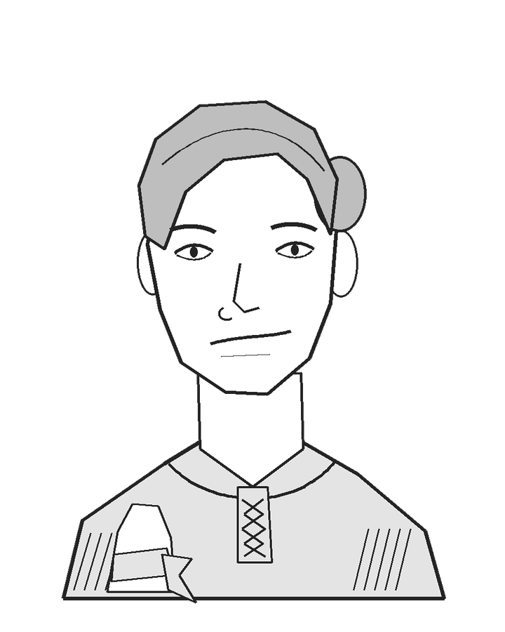 | Tavi Pell, Porter  Tavi appears to be in her late twenties or thirties: lean and wiry, with dark hair tied back. A cloth is knotted around one wrist and chalk is ground into her fingers. When Sorn gives an order, she watches Renn and Udel to see whether they will follow. Their ordinary work clubs are for discouraging rough handling, not evidence of trained guards.
She wants the porters safe together and their promised wages paid, or at least acknowledged if the money is gone. She knows the crate contents and packing method. She can prepare first-load cargo while Pella repairs, or spend five minutes packing selected locks and tools into a salvage sack that uses one additional ferry space. Point to this compromise when she discusses saving some value without carrying every crate.
"Iron doesn't drown. Renn does."
Payment from the office chest, or an honest agreement naming any still-unpaid wages, earns cooperation. She does not require characters to guarantee money they cannot pay. If Sorn insists on force, she tells him his authority ends at an unsafe order. Treat the other porters as people responding independently.
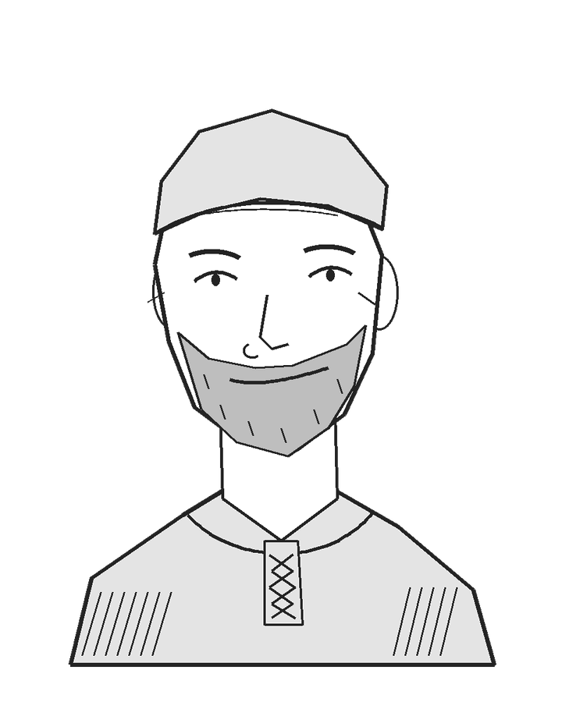 | Brin Vetch, Trader and Former Quarry Worker  Brin appears to be in his forties or fifties, broad-faced under a battered soft cap, with a close beard and clay caught in his cuffs. He sells cheap glazed pots; his surviving personal pack fits his ferry space. He has already wrapped the sound pieces and abandoned broken ones. His laugh is short and unamused. He tests a support by leaning on it, then wipes the mud on his coat.
He wants a route that does not depend on winning the argument. A local turned trader, Brin worked in the quarry when he was younger. He knows the upper stair is sound and can direct its routine preparation; he can suggest it himself when the argument stalls. He dislikes Harl being hurried and offers assistance without pretending the broken lower section is safe already.
"That step is bad. The whole hill isn't."
He cooperates with a clear ferry plan, but not indefinite assurances. If asked to lead volunteers to the stairs, he identifies who is carrying which piece of gear. Once safe, he reports the group's names by signal instead of leaving their fate mysterious.
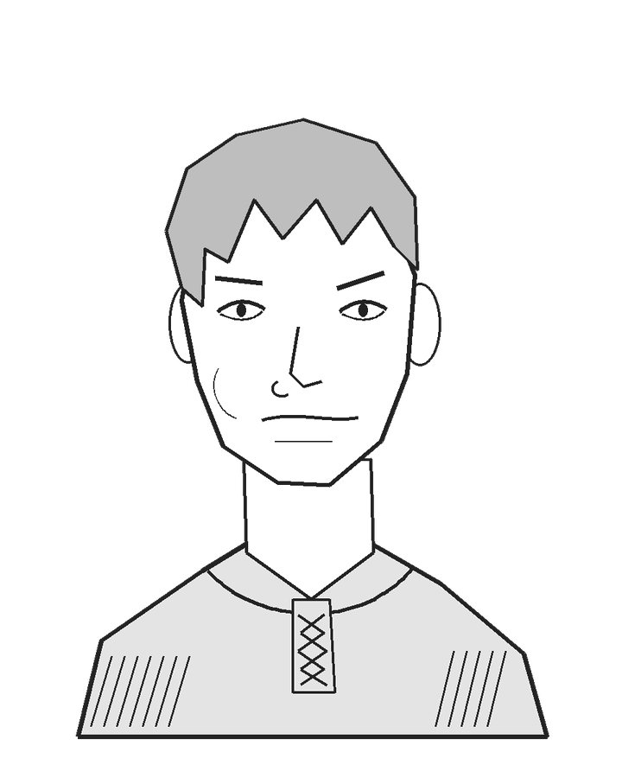 | Renn, Porter  Renn appears to be in his late teens or early twenties: long-necked and lightly built, with an untidy fringe that he keeps pushing out of his eyes. He grips his work club when an argument grows loud, then relaxes when somebody gives him a clear, useful job. A calm loading instruction usually gets a quicker response than a speech about courage.
He wants to cross with Tavi and Udel and to be paid for the work already done. He can help load the iron crates, ready a passenger group, or remain on either bank as part of an agreed cargo crew. Give him a question about the next practical step rather than making him a nameless extension of Sorn's authority.
“Which crate first? And who is taking the other end?”
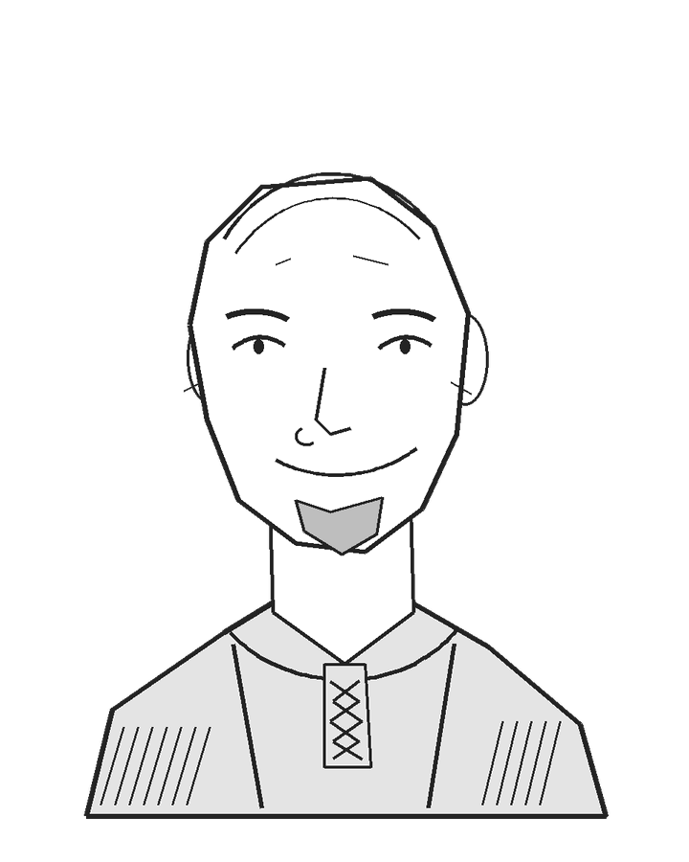 | Udel, Porter  Udel appears to be in his late thirties or forties, with a broad face, a close-shaved crown, and a short chin beard. His work vest is patched at the shoulder. He tends to look around before answering, checking whether someone is shivering or has been left out of an instruction.
He wants the three porters safe and their wages accounted for. He can carry, load, or receive cargo, and may suggest giving the dry blanket to someone colder than himself. He is willing to protect company property, but asks what an order would actually require before risking a fight.
“Give the blanket to her. I am still moving.”

Making an Agreement
Credible proposals get credible replies. "Passengers first" draws volunteers if it explains Sorn's losses. "Cargo first" needs a manifest and a route for the last people. Paying workers separately can change loyalties without making them villains. A simple witnessed receipt can say: equipment released for emergency use; goods saved or abandoned listed; damage observed; wages paid or still owed. Witnessing facts does not promise compensation.
If characters impose a plan, ask who believes it and why. A successful intimidation effect can obtain the key under the chosen rules. It cannot make a physically impossible schedule safe or erase everybody's memory afterward.

2. The Locality
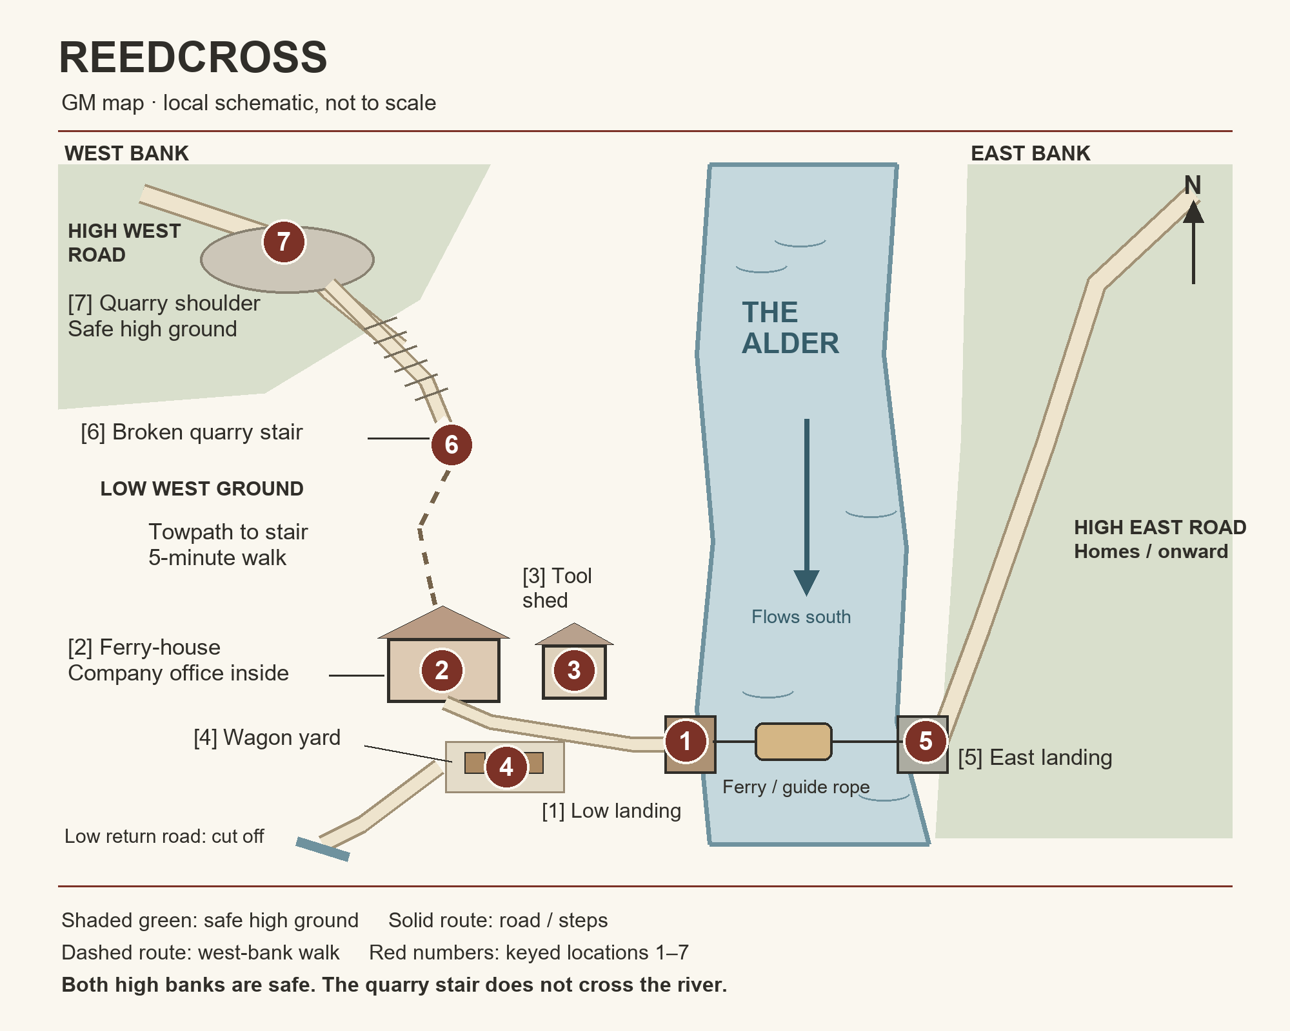
The GM map is a local schematic, not a measured survey. Its two high roads are not connected by another crossing. Locations 1–4 are within shouting distance and a short walk. Routine fetching there fits the stated readiness tasks; an extensive search does not. The five-minute walk to 6 is a real separate commitment, included in the quarry route's fifteen-minute preparation. There is no shortcut across the river hidden in the drawing.

1. Low Landing and Ferry
Water washes over the lowest step of a timber landing. Wet rope smells sharp against river mud. The ferry is a broad, shallow boat with a lowered boarding rail, a sound floor, and an operator's working space at the stern. Six worn places along the passenger rail make its usual capacity easy to demonstrate.
Pella holds the broken pin beside the hauling lever. She shows where the replacement belongs and points to the sound guide rope. Anyone looking receives this information without a test. The broken pin alone cannot bear the working strain; a stout replacement in the shed can. Pella can fit it with ordinary help.
Loading skids and hand rollers travel aboard the ferry. In the early-cargo example in section 7, two porters cross with two crates, roll them ashore, and carry them up onto the safe east road. They then stay east to receive later cargo while Pella returns. Cargo can travel later instead: send receiving helpers ahead, keep loading helpers west, and put them aboard the last cargo-carrying crossing. Routine handling with a prepared crew is included in the crossing time; a full boat of crates needs an agreed east-bank crew before it leaves.
The post and ferry-house sill carry old flood scratches. Pella uses these, the current, and the floating debris to explain what she expects the river to do. The characters need no specialist knowledge of rivers, flooding, or local history to understand her warning.
A character or NPC with an ordinary pack uses one of the ferry's six passenger-sized spaces; the pack fits with its owner. Large chests, bulky equipment, and other unusually large objects need extra room. Agree on their space requirements before loading. The capacity picture and examples are in section 7.

2. Ferry-house and Covered Bench
Whitewashed walls have a brown tide mark below the windows. A kettle sits cold on the hearth. Pella has spread a blanket over the covered bench for travelers waiting away from the water. Boots and elbows crowd it. A quieter conversation is possible inside the ferry-house or company office, but people are reluctant to leave the landing while the water rises. Characters can still suggest taking someone aside; establish who steps away and whether any work actually waits for them.
Outside, under the eaves, are two stout maintenance planks, a short sound ladder, and a coil of hand rope. Pella readily allows their use if asked and points them out when the quarry route is discussed. These are accessible without Sorn's key and sufficient for the prepared stair route described below. Carrying them can begin as soon as people agree to go. Taking them does not disable the ferry repair.
Behind a half-door is the company's cramped office: toll board, damp ledger shelf, two stools, and a small iron-strapped chest bolted below the desk. Sorn keeps its ordinary key on a separate cord from the shed key. The chest holds two days of owed wages for each of the three porters, plus toll change worth half a day's porter wage. Sorn kept the wage packets for the delivery handover, although payment is already due. For a ready-to-use coin example, pay a porter two silver per day: each two-day wage packet holds four silver, and one silver remains for toll change, making thirteen silver in all. Adjust this example to your game's economy; the wage money is not enough to replace the iron shipment. No guard, alarm, or trap is hidden here. Pella knows where the chest is; Tavi knows what wages are due.
With Sorn cooperating, someone not needed for ferry repair or loading can collect and pay the packets during the initial readiness work, without delaying it. Diverting necessary hands or forcing access is a different commitment. If someone forces the lock or removes the chest, state the time, noise, and risk before they commit, using the system's ordinary rules. Taking the whole chest adds one passenger-sized space; the small coin packets fit normal personal luggage. Sorn can agree to release the wages now; Tavi can count them and witness the payments. Paying wages from company funds records an existing debt settled, not a new reward; theft can cause objections and later claims without summoning an unseen guard.
If you want another voice in the opening dispute, Tavi can demand the porters' overdue wages while Pella and Sorn argue about the shed. Renn and Udel back her claim. This is a demand to settle the existing debt, not an extra fee for helping; payment can overlap the readiness work as described above.
A slate, chalk, dry paper, and a stub of charcoal offer ways to record an agreement. There is also drinking water and one dry blanket. Choosing who gets it can reveal priorities without changing boat capacity.

3. Tool Shed
The door is ordinary timber, with exposed hinges and a simple lock. Inside are hand tools, spare fasteners, and working rope. The smell is damp sawdust and oil. Sorn's key opens it; removing the hinges or forcing the door also reaches the equipment. Describe the door before requesting any roll.
Once equipment is accessible, the five-minute repair/readiness interval includes Pella choosing and fitting an adequate fastener. Do not add a secret search for the correct pin. A character may offer suitable equipment instead; Pella can recognize it without a contest of expertise.
Forcing entry has whatever time and noise the GM's system fairly assigns. Declare the likely cost and injury risk first. The door is not a disguised lethal trap. Sorn is angry about damage to the company's door and demands that whoever forced it pay for repair, or replacement if necessary. Witnesses may support him or the characters depending on whether they think forcing entry was justified. His demand is a dispute to resolve, not an automatic fine.

4. Wagon Yard and Cargo
Three crates rest on a low wagon under a tarred sheet. DRY is chalked on their sides. The nearest lid has swollen; the porters have a pry bar and know how to open it. Each crate contains enough iron locks, hinges, and tools to occupy two passenger spaces. The wagon and its cargo are separate: the wagon itself will not fit the ferry or stair and stays behind.
No live draught animal is waiting here in the default scenario. If you add one, the porters, Sorn, and some other travelers want it brought to safety too. Account for the animal's space, handling, and usable routes when adapting the inventory and timing in section 10. Small bags, seed, and the traders' personal packs are already included in their personal spaces. Extra salvaged property is not.
Sorn or a porter can spend five minutes selecting and packing a salvage sack of the small, higher-value locks and tools. It takes one extra ferry space, regardless of who holds it. Packing does not shrink the remaining shipment into free luggage. The sack's contents are taken from the three crates and count as the portion of that shipment saved.

5. East Landing and Raised Road
Stone steps rise from the east landing directly to a gravel road on high ground above the flood. Grass grows between the upper stones. Characters and other passengers can step ashore and walk straight up to safety. The lower steps grow wet, but the road remains dry and accessible throughout the default crossing window.
Arriving passengers move clear of the landing promptly, leaving room for unloading and Pella's turnaround. Ordinary disembarkation is included in the crossing time. The east-bank porters receive later cargo; other passengers can lend a hand, help someone up the steps, share the blanket, or watch the west bank.
There is space for everyone to shelter along the raised road until the weather passes. Looking back reveals the yard gradually disappearing; the sight can interrupt a quarrel more effectively than a speech.

6. Broken Quarry Stair Foot
A narrow towpath leads upstream to a stone stair climbing the west bank. Its lowest section has fallen away, leaving a shoulder-high gap between firm ground and the first sound steps. Water darkens the exposed stones, and one loose slab tilts when pressed. The failure is visible.
Brin knows this stair from former quarry work. He, Pella, or an inspecting character can explain the sound route: remove the loose slab, seat the maintenance planks or ladder on firm support, secure the hand rope to the sound upper post, and station helpers at both ends. The planks bridge the short gap; they do not span the river.
With that equipment and willing hands, preparation is routine work. The fifteen-minute approach-and-preparation allowance includes assessing the footing. It needs no mandatory climbing or construction test. An unsupported scramble, carrying a person alone, or trusting the loose slab is a different, openly risky plan.

7. Quarry Shoulder and High West Road
The steps end beside a disused stone cutting, with grass in old wheel grooves. Beyond it, a high road leads away from the river. There is room to sit without blocking people coming up. Ordinary packs and a supported adult can pass; the intact iron crates and wagon cannot use this improvised approach in the default plan.
The shoulder and east road belong to the same small locality but are not connected by a convenient second crossing. If people divide between them, establish a daylight signal before separating. Calling names or waving a bright cloth can confirm that a group reached safety. Reunion later is ordinary travel, not an adventure the characters must play.

3. Reedcross and the River Alder
The Alder is about thirty yards wide between its usual banks here and flows south. Reedbeds fringe the low west shore; east-bank stone steps rise to a firm gravel road. The current already draws the guide rope downstream and turns branches end over end. A strong, unburdened swimmer might cross early, but the moving water is visibly hazardous. Removing clothing or having a high strength score is not by itself a safe crossing method: judge the actual plan, current, cold, debris, rescue arrangements, and chosen game's rules. As the flood rises, the debris and current can make unaided swimming impracticable; warn before someone commits. Upriver rain is bringing a faster rise. Reeds bow and disappear, the lowest step vanishes, and timber striking the posts interrupts conversation. Section 6 gives those changes a consistent order.
Reedcross is a ferry-house, shed, wagon yard, and landing on the low west bank. The few homes beside it were emptied earlier this afternoon; these are not the dry east-bank homes the waiting residents are trying to reach. Eighteen adult travelers are waiting; Pella is additional. The low return road is cut off. Upstream on this same west bank, the broken quarry stair can be made usable with the planks or ladder and rope outside the ferry-house. It reaches a high shoulder safe from the flood, not the other side of the river. People can choose it early to avoid relying on the ferry, or divide between the routes to leave more ferry room for cargo. Those using the stair remain west, their intended crossing unfinished; intact crates cannot use its improvised approach.
Reedcross Carrying Company holds the toll concession and uses the ferry-house's back room as its local office. Pella owns and operates the boat for a share of the tolls. Sorn is the company's local cargo agent, not its owner. Unpaid maintenance charges have soured their working arrangement; each believes the other has been made to cover costs that belong to the company.
The three crates contain locks, hinges, hand tools, and iron fittings promised to east-bank customers repairing workshops and a communal grain store. Losing them will delay that work as well as cost money. The company bought the shipment on credit, and Sorn signed a personal guarantee. He can show the order list and guarantee. No distant villain or invented regional history is needed to make the debt matter.
Earlier, floating timber struck the hauling lever and broke its retaining pin. The hull, guide rope, and opposite anchorage are still serviceable. Sorn locked the tool shed during the maintenance dispute, before the danger became clear. He now fears that handing over the key means losing his only leverage over which load goes first. The tools do not belong to him personally; he can release them for emergency use and record why, though he fears being blamed.
For orientation, the ferry has six passenger-sized spaces, in addition to Pella at the controls. One person with ordinary kit uses one space; one intact crate uses two. People and crates share those same six spaces. Section 7 shows the grid and examples; the picture can be shown to players. Pella and helpers can repair and board it in about five minutes; another five gets a prepared load across, tied up and unloaded. Returning and boarding the next waiting load takes about five more. The reference at the back collects the schedules.

4. At the Landing
Read or paraphrase:
The Alder runs brown between the banks, carrying branches faster than a person could walk beside them. The road behind you ends in a sheet of moving water. Across the river, the raised road is still clear.
A broad ferry bumps against a timber landing. A woman in patched oilskin holds up a broken iron pin. Between her and three sheeted crates stands a man clutching a leather document case.
"The tools, Sorn. We can argue about who pays when everybody is over."
"And when the iron is gone, whose name goes on that loss?"
Behind them, Dema lifts her seed sack onto a bench. "Mine goes on the seed. Those households are waiting for it." Upstream, a broken stone stair climbs toward a high shoulder on your side of the river.
Ask what the characters do. Pella immediately points out the key, repair, and safe high ground; Tavi can explain the shipment, and Brin knows the quarry stair. Do not perform the entire quarrel before allowing action.

5. What the Characters Can Learn
Give ordinary available information through the people who know it, without a roll merely to hear them. Pella can explain the repair, ferry capacity, and usable crossing window. Tavi can explain the shipment and portable salvage. Sorn has the shed key and company records, and can explain procedure, necessary paperwork, and the porters' unpaid wages. Brin knows the broken quarry stair and accessible gear. Both high refuges—the west quarry shoulder and the east raised road—are safe from the default flood. Make the complete population and cargo inventory available when the party begins planning.
Explain the stair on first mention: an old west-bank quarry access with a broken lower section that can be supported using the accessible planks or ladder and rope. It reaches high ground, not the east road. The ordinary plan carries people and personal packs, not the wagon or intact iron crates. Bulky property and added animals need a separately credible carrying method; do not promise their safety or declare them automatically lost before considering the actual proposal.
Tell players what is uncertain too: a new search's duration, improvised swimming, damage caused by forcing the crates or shed door, or unusual equipment. An uncertain structural assessment or reading Sorn's motives can justify an appropriate check; neither is a universal test of every hidden fact. State what success, ordinary failure, and any critical-failure rule can mean before rolling.

Skill and Faster Work
A character's relevant skill can improve an outcome or shorten repair or preparation. Decide the possible saving and required help before the attempt. If the roll only offers a speed bonus, ordinary failure leaves the normal task duration rather than causing an unannounced collapse. If your game uses critical failures or botches, the GM determines additional consequences according to those rules and the circumstances. This does not remove competent NPCs' ability to complete their stated routine work.

6. Pressure and Passing Time
Do not run a real-time stopwatch or punish the players for thinking. Describe the rising water and let people speak and act. Advance fictional time when something in the world actually takes time: repairing, preparing the stair, a crossing, a search, or a sustained in-character argument. Let the players know the likely cost before they commit. Brief exchanges can happen together; answering questions about your description is free. For a sustained standoff, a useful default is to warn, "If this continues, about five minutes will pass," and give the characters a chance to break it off before advancing the tally.
Keep a simple GM tally. Convey the usable time and warn before a plan loses its safety margin. Pella can speak in approximate trips: “We might have three crossings before the landing goes.” If players ask for minutes or help checking a plan, give an estimate consistent with the GM schedule. Expert knowledge can improve an estimate, not make the flood's behavior exactly predictable. Parallel jobs share elapsed time only when different people have the needed gear and roles.
Minute | Describe | What remains possible
0 | Bottom step awash; scattered floating timber. | Repair, negotiation, or starting the stair.
15 | Water enters the lowest yard; Dema lifts her sack. | A ready boat needing four crossings can leave now and make its last west departure at 45.
30 | The house-to-landing path is covered by shallow moving water. | Pre-staged ordinary boarding still fits the model; fresh errands need warning and adjudication.
45 | The west approach is at its last usable stage; swift water and larger debris are overtaking the landing. | A ready boat may depart exactly now. Later departures lose the default guarantee.

At minute 45, the prepared stair's last person must also have cleared the low approach for the routine route to guarantee safety. The upper steps and both high refuges remain safe.
Material changes in the fiction can alter the forecast openly. Do not secretly tighten the clock because success looked easy. A ferry that leaves west at minute 45 completes its loaded crossing and unloading at 50 under the default plan.
After the safe window ends, explain changed risks before any action: concealed footing, larger debris, harder boarding, and cold moving water. Use the chosen system's hazard rules. Dangerous late action may still succeed, but it is no longer the routine, test-free solution.

If the Characters Do Not Take Charge
People keep acting. At minute 10, Brin invites four other independent traders to use the stair. They take the accessible gear, prepare the approach by 25, and clear it by 45. At minute 20, Sorn accepts a witnessed record: equipment released for emergency use, goods abandoned to save people, and the witnesses' names. This gives him an account for his employer and he releases the key. Pella and the porters are ready at 25; ferry departures at 25, 35, and 45 provide eighteen passenger spaces.
With those five traders on the stair, thirteen travelers remain for the boat. All three to five characters also fit if they cooperate, for sixteen to eighteen passengers; Pella uses her operator station. The porters load and assist people rather than the company's iron shipment. The three crates and wagon remain west; the ferry spaces are reserved for people. This fallback assumes the gear, workers, and routes remain available. Describe changed consequences honestly if the characters have altered them.
Competent NPC self-rescue is intentional: people act to preserve their lives. The characters can improve the outcome and shape how people treat them and each other. If the players decline the predicament, resolve their chosen departure and continue the campaign. Use the established setting and chosen rules for its consequences; the default flood does not require killing characters who declined to take charge.

7. The Ferry and Workable Plans
Ask who works, what travels, and when. Use the schedules as adjudication tools, while considering credible alternatives the players propose.

The Six-space Ferry
The ferry has six passenger-sized spaces, shared by people and cargo. One person with ordinary kit occupies one space. One intact crate occupies two adjacent spaces. Pella works at a separate operator station and does not occupy any of the six spaces.
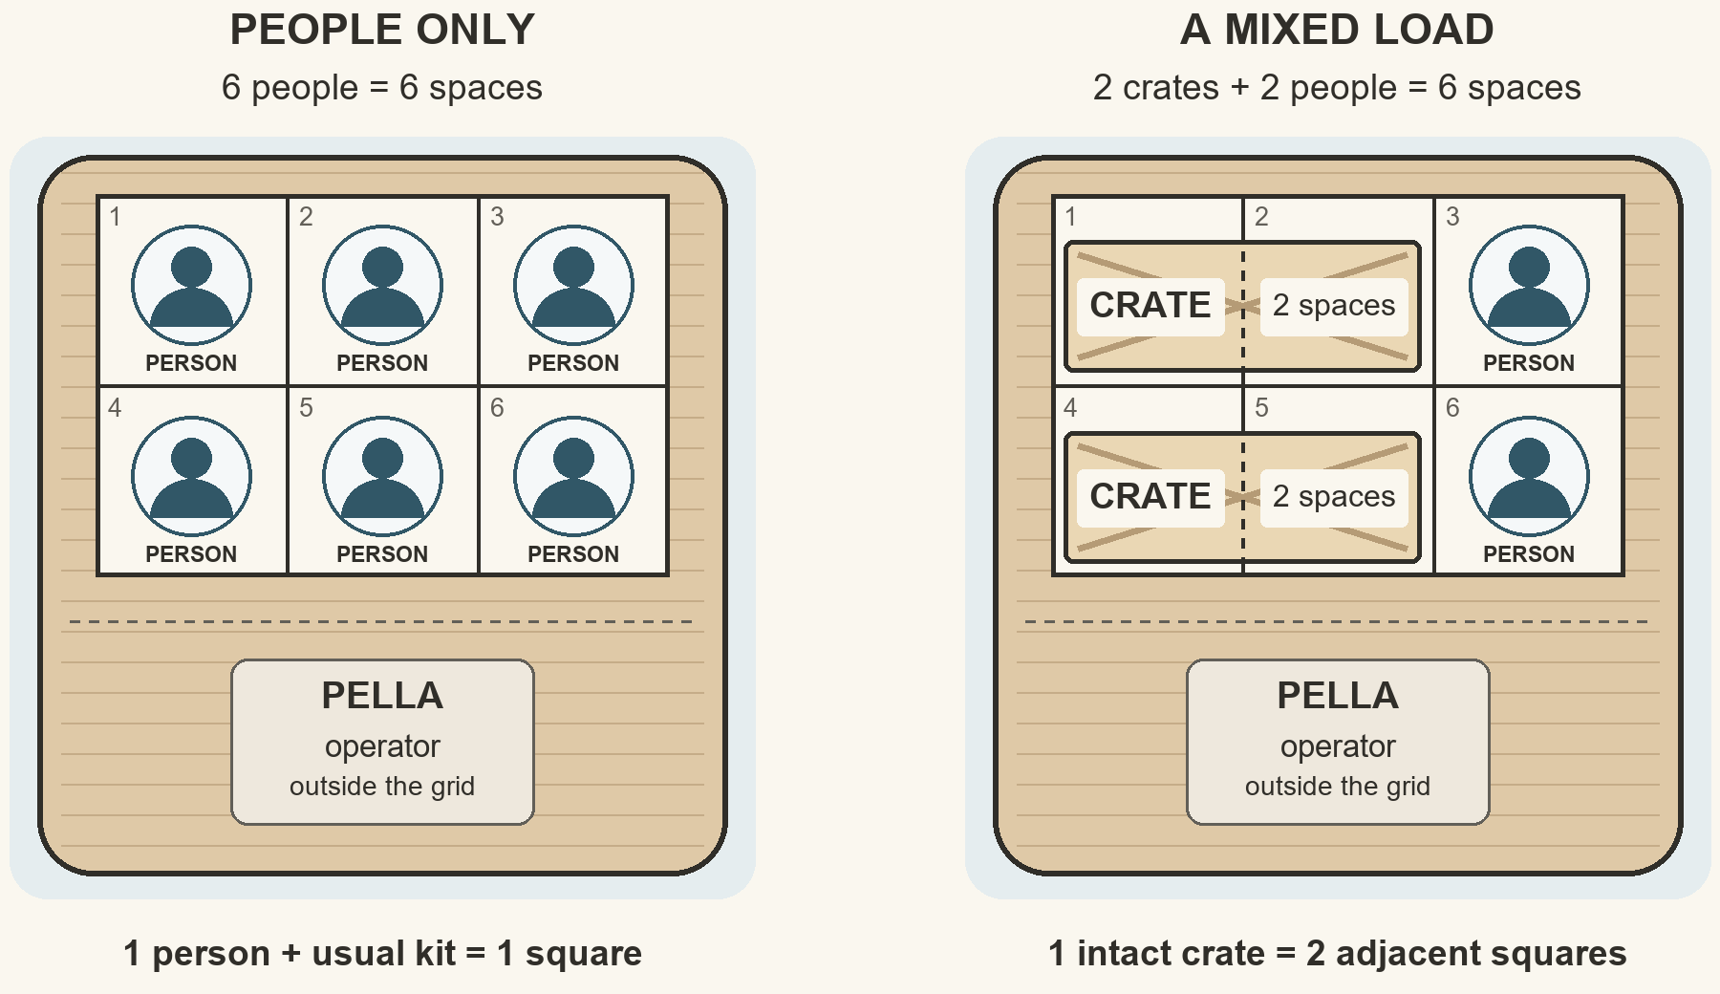
Show this picture to the players when Pella explains capacity. It is a capacity diagram, not a measured tactical deck plan: the squares have no stated distance. People and crates can share a crossing, but their combined use must not exceed six spaces.
There are eighteen travelers plus three to five player characters: twenty-one to twenty-three passengers, not counting Pella. Three crates use six spaces in total. Thus people alone require twenty-one to twenty-three spaces and four crossings; everyone plus all three crates requires twenty-seven to twenty-nine spaces and five crossings in total. Five crossings provide thirty spaces. The crates do not require five additional crossings.

Crossing Time
Time starts when the party arrives at the low landing. If the shed opens immediately, Pella and helpers spend the first five minutes fitting the pin and boarding the first load. Record departure when they push off from the west bank. Over the next five minutes she hauls the ferry across, secures it to the east landing, and gets that load ashore. During the following five minutes she returns west, ties up, and boards the next waiting load. Thus west-bank departures can be at 5, 15, 25, 35, and 45 minutes after arrival. These are all departures toward safety, not alternating departures from the two banks. The final boat may leave at 45 and land at 50; it does not need to return.
The routine pace assumes prepared loads and helpers. New searches, violence, or an unprepared load can add time; explain that before the choice. Once the plan is clear, summarize repeated crossings unless someone makes a consequential decision.

Loading and Unsafe Shortcuts
Six spaces is the stated safe working capacity in these conditions, not a target to exceed on a lucky roll. Passengers keep their usual kit with them; the operator's station is not a seventh passenger place. Two crates and two people fit; three crates fill the boat without passengers. Pella explains this while loading and refuses a manifest that exceeds it.
If another capable operator takes over and insists on overloading, describe the low rail, reduced freeboard, and the ferry's sluggish response before departure. Offer time to unload. Once committed, use your game system's appropriate handling or water-hazard rules: shipped water, a load shifting, loss of progress, injury, or cargo thrown overboard are possible consequences, not automatic drowning. A failed attempt can use time and worsen the next decision. A success gets that crossing through; it does not certify a higher safe capacity for later trips. Suitable flotation or transport abilities may genuinely change the limit after the GM evaluates the specific equipment.

Passenger Priority
Release or obtain suitable equipment, repair, and organize the first load. Twenty-one, twenty-two, or twenty-three passengers fit in four crossings: six, six, six, then three to five people. With prompt readiness, arrivals finish at 40. Up to ten minutes of additional delay still permits the final departure at 45 and arrival at 50.
Harl can go early without changing totals. Sorn can stay with the final group to witness abandonment if he chooses. Pella's empty returns do not consume passenger spaces.

A Portable Salvage Compromise
Packing the salvage sack of selected locks and tools takes five minutes and adds one space. Everyone plus the sack still fits four crossings for every intended party size. If repair and packing occur sequentially, first departure is 10 and last is 40, leaving five minutes for other delay. In parallel, first departure is 5 and last is 35.
Assign the workers: Pella repairs; Tavi packs; Renn and Udel help ready passengers. Sorn can supervise packing or complete the necessary paperwork; allocate separate hands if both jobs must happen together. The salvage sack preserves part of the goods' value and may reduce the credit loss. The porters' existing wages can be paid separately from the office cash.

All Three Crates by Ferry
Everyone plus all three crates takes five loaded crossings in total, not five cargo-only crossings. The six-space picture shows the first crossing: two crates and two porters. Those porters remain east to unload and receive later cargo. The second crossing takes the last crate and four people; the remaining fifteen to seventeen people use the last three crossings. Pella operates every crossing from outside the grid.
Crossing | West departure | Passengers | Intact crates | Spaces used
1 | Minute 5 | 2 porters | 2 | 2 + 4 = 6
2 | Minute 15 | 4 people | 1 | 4 + 2 = 6
3 | Minute 25 | 6 people | 0 | 6
4 | Minute 35 | 6 people | 0 | 6
5 | Minute 45 | 3–5 people | 0 | 3–5

The total is twenty-one to twenty-three passengers and three intact crates, using twenty-seven to twenty-nine of the thirty available spaces. This gives Sorn early cargo priority without asking Pella to handle heavy crates alone. The last people arrive at minute 50. Empty return legs are included in the timetable; no final empty return is needed.
Saving everyone and every crate is possible without a mandatory test if preparation begins immediately. This is not automatically an either-people-or-property dilemma. Its weakness is lack of margin: any extra delay pushes the fifth departure past 45. Sorn and Pella understand the problem and can explain it before agreement. Players may accept or reject the narrow plan.
A stair backup needs prepared gear and everyone relying on it already at the stair, beginning the climb by minute 25. Deciding to walk there at 25 is too late for the default guarantee. It cannot rescue a final group still at the ferry when a delay is discovered at 35 or 40.
Pella or Brin explains this before anyone commits, using approximate in-character estimates rather than reciting the GM's timetable. For more margin, either can suggest dividing the work: five volunteers take the stair early, and everyone else plus all three crates uses four ferry crossings. That leaves ten minutes for additional ferry delay. See Divide the Work below.

Cargo Can Travel Later
The table above is an early-cargo example, not a required order. For a five-character party, a later-cargo plan is:
Crossing | West Departure | Passengers | Intact Crates | Spaces Used
1 | Minute 5 | 6 people | 0 | 6
2 | Minute 15 | 6 people | 0 | 6
3 | Minute 25 | 5 people | 0 | 5
4 | Minute 35 | 4 people | 1 | 6
5 | Minute 45 | 2 people | 2 | 6

Send Tavi and another capable receiving helper east early. Keep Renn and Udel west as the final two passengers: they can help load the fourth crossing, then load the final two crates and travel with them. Tavi and the helper receive both cargo crossings. Other passengers can help the west loading crew before leaving. With three or four characters, remove two or one passengers from the third crossing; the crews and crate totals stay the same.
Any revised order needs both a receiving crew and a west-bank loading crew until the final cargo departure. Two wholly cargo-only crossings would leave only eighteen passenger spaces in the other three, so that version also needs the stair or another capacity change. An entirely crate-filled crossing can work only when its handling crews and the rest of the passenger plan have actually been provided for.

The Whole Group up the Stair
Take the accessible ladder or planks and hand rope, use willing helpers, and follow the preparation at location 6. Five minutes to reach it and ten to inspect and secure it are followed by twenty minutes to move everyone through the supported gap and onto the shoulder.
That movement allowance covers all eighteen travelers, all characters, and Pella: twenty-two to twenty-four people. It includes personal packs and helping Harl. The printed plans use the same conservative twenty-minute movement allowance for smaller groups; a genuinely faster method calls for an openly revised forecast. Start at 0 and everyone is safe at 35; start by 10 and the last person clears the low approach by 45. The ferry, wagon, and intact crates remain below. The salvage sack may go with a carrier on the stair without using a ferry space, but its five-minute packing task still needs workers and a place in the schedule.
No routine stair test is required with the stated preparation. Extra delay, missing equipment, unsupported climbing, or an attempt to haul whole crates changes the plan. State the new requirements and risks, rather than treating all climbing as automatically easy or automatically fatal.

Divide the Work
Four independent traders, including Brin, and one character can take the stair gear and prepare their route while the others ready the ferry. Those five clear the stair by 35 if they start immediately. Sixteen, seventeen, or eighteen people remain to travel by ferry, depending on party size; adding six crate spaces still needs only four crossings.
Both routes can operate in parallel because Pella stays with the ferry and Brin can guide the stair crew. Four ferry crossings allow ten minutes of extra delay. Obtain volunteers rather than quietly assigning five inconvenient people to danger. Agree on the high-ground signal, and do not count the stair character as a ferry passenger too.

Abilities, Force, and Departure
Suitable flight, water control, strong hauling magic, or another transport ability should actually change the rescue. Establish duration, passengers, carried mass, landing place, and return journeys using the real character rules.
Swimming this debris-filled river is visibly hazardous for ordinary people; a sound rope or competent magical escort may change that. A homemade raft requires a credible build, capacity, and crossing method, not one generic "creativity" roll. Judge the specific proposal and distinguish necessary tests from routine preparation.
Breaking the shed or threatening Sorn can work. Only use combat if actions actually produce it. Ordinary porters withdraw when hurt or offered a safe exit; no elite reinforcements arrive to restore the argument. Characters can also take passage and leave.

8. Choices during a Working Rescue
These situations arise from people and commitments. Use only those the plan makes relevant; none is a compulsory encounter.
If Dema has not already found a covering, she notices the tarp still sheltering crates scheduled to be abandoned and asks for it to protect seed and dry clothing. Sorn wants a witness that removing it increased the goods' damage. They can both get what they need: name the decision and its reason. Hearing and understanding the request needs no roll.
Harl stops at the boarding rail, annoyed by a porter grabbing his elbow without asking. He is not sabotaging the timetable. A brief practical exchange and offered hand resolve it within routine boarding. Turning his objection into a prolonged humiliation adds an actual argument; warn before charging delay.
Tavi asks Sorn to settle the porters' wages from the office cash before arguing about the shipment again. He wants each payment recorded. With Sorn cooperating and a person free of ferry duties, retrieving, paying and witnessing the packets can overlap readiness; it adds no automatic delay. State any cost if the plan instead diverts needed hands or forces the chest. If that money has gone, record wages still owed separately from lost cargo; a receipt is evidence, not imaginary payment.
An early passenger on the east bank calls across, asking whether a person still west is coming. Give the player's answer room. Honest uncertainty can motivate a backup route; an invented guarantee may later strain trust. This changes relationships, not secretly the river's speed.
If someone proposes staying for property, ask what that property means to them and who will help. Make the available safe exit explicit. Voluntary risk is a meaningful choice; a stranger's unilateral decision that another traveler must stay is not consent. Other people can object or leave independently.
During a smooth series of crossings, summarize repeated operations. Describe an arrival, a visible flood change, and one consequential request. Do not add a random rope failure, wandering monster, or compulsory skill montage merely because the transport arithmetic has become easy.

9. Consequences and the Stopping Point
Finish once everyone has reached high ground, left by another route, or made their last immediate choice about remaining below. Resolve any active late hazards before cutting away from the scene.
Read the boarding or stair list aloud. Establish who is safe, injured, missing, or dead according to actual adjudication. No death is required. Name saved property separately: personal belongings, seed, salvage sack, intact crates, office cash, and boat. The wagon is abandoned in the default routes.
If Pella took the final ferry across, the boat is safe at the east landing by default, though its west post and landing may be lost. Mooring on the high side is included in ordinary unloading. If everyone used the stair, the unattended boat remains on the low bank; decide its eventual fate from the conditions or leave recovery for later. The crossing stays closed while the river is dangerously flooded, even if the ferry survives.
Give Pella one reaction grounded in events. Passenger priority earns practical gratitude. A workable cargo compromise earns the same, perhaps grudgingly. Coercion can save lives and still leave Pella unwilling to work with the characters again. She does not pretend a damaged house or shed never mattered.
Sorn has his own reaction to the characters' actions. A witnessed record lets him stop rehearsing his defense for his employer. Saving the goods does not automatically repair his relationship with the porters. If he abandoned them, lied about the schedule, or left their wages unpaid, Tavi may decline further work on the spot. If he released equipment and accepted losses, neighbors may acknowledge it without forgiving every old debt.
Offer a concrete settlement: return borrowed tools; write the factual receipt; record wages paid and any still owed; place any salvage with named custodians; or postpone disputed maintenance debt without pretending it disappeared. Any payment comes from actual money available, translated into the GM's economy. There is no automatic treasure hoard or guaranteed job offer.
On divided high ground, use the agreed signal to establish immediate safety. Invite each player to offer a sentence about what their character does when the danger passes; do not require a closing performance. Close with the wet receipt, shared blanket, or river covering the old approach. Continue into your campaign if useful, or leave rebuilding offscreen.

10. Adapting This Scenario
Before running, complete these decisions for the actual table:
- Choose the party's connection from Using Reedcross in your campaign above, or use its existing circumstances. Make any work agreement and the consequences of delay clear; do not assume every party has the same priorities.
- Place a low landing, a river, two high shoulders safe from the flood, and an unusable low return road. Rename people and the concession if desired; retain their material relationships.
- If adding an army, raid, blight, or other campaign danger, establish its reach and timing before play. The printed safety and transport schedules assume the flood alone. Adjust the NPCs' advice and fallback plans, routes, and available time if the added threat changes them. Disclose those consequences before the party chooses; do not introduce the threat afterward to invalidate a chosen refuge.
- Use beginning characters who can be threatened by moving water and loss of shelter. Check real abilities rather than assuming a particular level number. If easy mass transport exists, accept a different kind of session.
- Translate a person with ordinary personal kit into one space. Decide how unusually large characters, armor loads, mounts, dependent passengers, or bulky loot affect capacity. Re-run the arithmetic after any inventory change.
- Keep competent NPCs' stated repair, ferry operation, and properly prepared stair work reliable. Optional checks may improve or shorten a task, or assess genuinely uncertain conditions; ordinary available information is not gated by a roll. Apply critical failures or botches according to the chosen rules and the GM's situational judgment.
- The printed east landing permits ordinary disembarkation throughout the crossing window. If you want rising water to make that exit dangerous, establish the changed hazard and allow for any extra unloading time before players choose a schedule. This is an adaptation, not a hidden complication in the default plan.
- Identify rules for forced entry, coercion, combat, swimming, exposure, falls, and late-departure debris before they arise. Establish warning, possible injury, rescue, and recovery under those rules; this manuscript supplies no universal damage numbers.
- Choose consequences for an ordinary opponent's injury and willingness to withdraw. The company party consists of workers, not a balanced combat encounter or a source of mandatory experience points.
- Price the locks, tools, debt, three two-day wage packets, and half-day toll change in the local economy. Preserve Sorn's fear without requiring a named guild, monarch, religion, or regional trade history. A witnessed inventory is evidence, not binding universal law.
- Confirm the table's boundaries concerning drowning, threatened livelihoods, disability portrayal, and intimidation. Changing a boundary may require changing the threat, not merely omitting a descriptive sentence.
- Keep a GM time tally; give players a practical forecast in trips or minutes and disclose a plan's last safe commitment point before they choose it. No player-facing stopwatch is required. Use ordinary judgment for new tasks, not an undisclosed discretionary deadline.
- Let this encounter occupy as much or as little play as the party gives it. Test clarity, credible behavior, and workable choices, not whether it fills a whole evening.
System-neutral does not mean preparation-free. The flood timing and supported stair are explicit play assumptions, not engineering or safety advice.

11. GM Quick Reference
Situation: The west approach is flooding. Pella can repair her ferry once Sorn releases the company shed. His iron shipment matters to customers and his own credit; the travelers need both safety and the east road. A broken west-bank quarry stair offers a real escape, but not the crossing they came for.
Item | At the table
People | Eighteen adult travelers plus three to five characters. Pella is additional in her operator station.
Ferry | Six passenger-sized spaces: one person with normal kit uses one; one intact crate uses two. Pella is outside the grid. See the capacity picture in section 7. No routine overloading.
First readiness | Five minutes from access to tools, with helpers boarding the first load while Pella repairs.
Loaded trip | Five minutes from west departure through east-bank unloading.
Return | Five minutes through west-bank boarding of the next prepared load.
Latest departure | Minute 45 after arrival, inclusive. That last boat lands at 50; no final return is needed.
Salvage sack | Selected small locks and tools from the crates; five minutes to pack, one additional space. Not extra goods or all the cargo compressed.
Quarry stair | Five-minute walk, ten-minute preparation, twenty-minute supported movement. Clear the low approach by 45. Accessible gear is outside location 2.
Office cash | Three packets of two days' porter wages, plus half a day's wages in toll change. Chest key is separate from the shed key. Wage packets can be paid during readiness by a free helper. Whole chest: one extra space, with unbolting or forcing time declared first.

Immediate ferry schedule: west departures 5 / 15 / 25 / 35 / 45; east unloadings complete 10 / 20 / 30 / 40 / 50. Every number is minutes since the characters arrived, not a real-time player clock.
Plans: People without intact crates need four crossings, leaving ten minutes for extra delay. People plus the salvage sack also need four; packing can overlap repair with different workers. People plus all three crates need five, with no extra-delay margin; use either worked manifest in section 7 or verify another crew plan. A stair backup requires prepared gear and its users already at the stair, beginning to climb by 25. Five volunteers on the prepared stair leave the others and all crates needing four ferry crossings; the stair crew must set out by 10. Everybody, including Pella, can use the prepared stair in thirty-five minutes, leaving the boat and intact crates below.
Pressure: At 15, water enters the yard; at 30, it covers the landing path; at 45, the routine safe departure/low-stair clearance window ends. Announce changing water and likely time costs. Do not charge player questions or silently move the deadline.
If Nobody Leads: At 10, Brin and four other traders take the stair; they clear it by 45. At 20, Sorn releases the key for a credible witnessed record of the loss. People board ferry crossings at 25, 35, and 45; all remaining travelers and three to five characters fit if the routes and gear are available. The three iron crates and wagon remain west.
End: Establish people's safety, saved property, wages paid or owed, the boat's fate, and immediate relationships. Use the result in your campaign or stop here. A successful rescue needs no compulsory fight or second calamity.

Credits and Publication Notice
Produced by Terrible Gamers with writing, editing, and design done by Scott Mills and Mira Vale.
Public draft · v0.9. Published 15 October 2026.

Copyright Notice
Copyright © 2026 Scott Mills in his original contributions and any protectable selection and arrangement, to the extent copyright applies and the rights are held by him.

Art and Portrayal
The eight NPC thumbnails were created for Reedcross. Ages and appearances are portrayal cues that a GM may adapt.

Current game: Free League Publishing. Background and publication history: Wikipedia.

